**The Modelling for Dual-motor Electrical Vehicle**

Guangmin Qu   
Department of Electrical & Computer Engineering  
McMaster UniversityHamilton, Canada  
qug4@mcmaster.ca

**Abstract: Due to the increase in global carbon emissions, the greenhouse effect is becoming more and more serious, which makes electric vehicles more concerned. More and more vehicle manufacturers have begun to release their new dual-motor electrical vehicle models. This paper will focus on analyzing the combination of motors and torque split strategies of dual-motor electric vehicles, and the final purpose is to find an efficient solution. The simulated model is based on Tesla Model 3, and the selected motors are Tesla 3D1 permanent magnet synchronous motor and the 3D3 induction motor. And through UDDS, HWY, and US06, three drive cycles for environmental testing. All the result is from MATLAB/Simulink software simulation. The simulation results show the electrical cost under different motor placement plans and torque split strategies.**

1. Introduction

In recent years, due to the development of industrialization, environmental problems such as global warming have become more and more serious. According to the EU report, the transportation contributes 23% of greenhouse gas emissions (GHG), and road transportation contributes 73% amount the whole transportation section [1]. As a result, human beings are trying to change the way of daily travel to reduce carbon emissions and use energy more efficiently.

Vehicle electrification is a viable solution to GHG emissions. Compared with traditional internal combustion engine drive vehicles (ICE), electric vehicles (EVs) are light, have high engine efficiency and can decrease GHG in the urban area [2].

Since Tesla released dual-motor electric vehicles in 2014, Jaguar, Mercedes-Benz, and Porsche have also launched dual-motor electric vehicles. This is because of the obvious advantages of dual-motor electric vehicles compared to traditional single-motor electric vehicles. First, dual-motor vehicles have more power. Second, the two motors make AWD possible since the two motors are placed on the front and rear axles of the vehicle and drive them separately. This allows for AWD without the complicated drivetrain. Finally, dual-motor EVs are more energy efficient. According to the data from Oak Ridge National Laboratory, the 2021 Tesla model 3 AWD version consumes 134MPGe and the 2021 Tesla model 3 RWD version consumes 142MPGe [3].

The reason the dual-motor vehicle is efficient is that the two motors can split the torque in various ways. Shifting the propulsion power between the axles makes the torque distribution flexible. This character could lead each motor to work under the optimal efficiency status. Compared with the single motor EV, dual-motor EV always has high motor efficiency, which overcomes the penalty of the additional mass of the motor.

1. Motor configuration

The application of dual-motor drive technology such as the Tesla Model S D series has also prompted the research of dual-motors. As a result, scholars in the automotive field engaged in EV multi-motor research are rising.

In general, their research focuses on motor configuration, motor energy management, and motor control strategies [4]. Therefore, this section will focus on the motor configuration.

Through the literature, researchers solve the functional problem of EV by configuring the number of motors.

*2.1 Drivetrains*

The single-motor drive scheme has a simple structure and is easy to integrate. Still, due to the lack of flexibility of this scheme, it cannot adapt to complex traffic situations, and it isn't easy to improve performance [5]. For example, because of the character of the motor, the time of getting maximum torque is shorter than ICEs, and that causes the wheel-spin issue during the acceleration and the wheel-lock during the break; this feature degrades EV performance in road conditions with a low coefficient of friction [6][7]. In addition, the size of the single motor is bigger than other solutions, which affects the fuel efficiency [4]. Thus, more research has turned to the multi-motor field.

The multi-motor solution is obviously more flexible, and the performance of the EV under different road conditions can be optimized by combining different types of motors or changing the motor positions. However, multi-motor increases the weight of the EV, leading to the friction between the wheels and the ground increasing, which affects energy efficiency [5].

Through the study of the first two configuration methods, Dual motors are a compromise solution to reduce the energy cost. The researchers intensively investigate the dual-motor powertrain to achieve the optimal solution between flexibility and efficiency [6].

As shown in figure.1, the motors in dual-motor EV are working on the front and rear axles independently. Each motor has an inverter and final drive; the gear ratio might differ. The EV's battery is under the center of the chassis, which connects to two inverters' duty are to adjust the frequency and the voltage of the output electrical to change the torque and speed of the wheels. 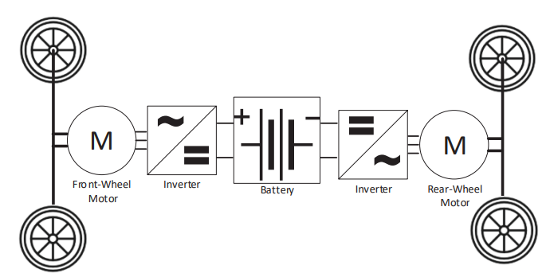

Figure.1 The structure of dual-motor EV [7]

*2.2 Motor types*

In general, the electric motors mainly used in EVs are the permanent magnet synchronous machine (PMSM), which is usually compact and high efficiency, and the induction machine (IM), which has low cost and simple structure [9].

PMSM has high-performance permanent magnets as the rotor, which synchronizes the rotor speed to the current frequency of the stator windings. The rotor speed of the IM is slower than the rotating magnetic field speed generated by the stator because in order to meet the characteristics of the induced current generated by cutting the magnetic field line, it is also called an asynchronous motor.

In terms of performance, the most general description is that induction motors are robust and more suitable for high-performance, high-speed conditions because of the more comprehensive motor speed range. In contrast, permanent magnet synchronous motors are more suitable for high energy efficiency requirement application and frequent start and stop conditions because permanent magnets reduce the energy loss of electromagnetism [10].

1. Torque split strategies

For the electric vehicle with two individual drivetrains, each drivetrain can operate independently [11]. The propulsion can be distributed to two motors with any proportion when the driver is driving the EV, whatever acceleration or deceleration. Adjusting and optimizing the relationship between two drivetrains could give the EV high energy efficiency or extraordinary driving performance. That is the value of torque split strategies.

To make the EV work under high-efficiency mode, the system should split the torque scientifically. The motors and inverters are the most significant energy cost factors because all the electrical power is transferred to mechanical power via the inverter and motor and some energy will be lost by heat or used to magnetization that is not directly transferred to torque [12]

The parameter which affects the efficiency of the inverter and motor is the axle torque M and motor speed n. As shown in function (1), the efficiency of the drivetrain combines the efficiency of the inverter and motor which relates to the energy loss during the electrical power transfer to mechanical power .

(1)

The overall torque split logic structure is shown in figue.2. Because of the EV should follow the drive cycle during the road test, the optimizer block`s duty is to keep the vehicle speed ,at the same time, distribute the real-time torque request is . The next step of the system is to deliver the distributed torque M1 and M2 to the drivetrain, then input the final torque to the vehicle for the speed control.

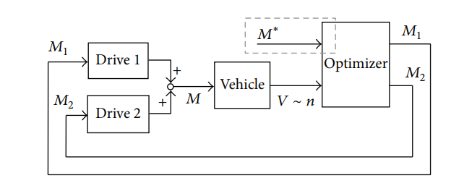

Figure.2 The drivetrains` optimal logic [13]

*3.1 Constant split*

Traditional fuel four-wheel drive vehicles usually use the constant split method to bring drivers a better driving experience. For electric vehicles, the use of Constant split can not only improve the driving experience, but also optimize energy consumption.

The function (2) is how to calculate the torque split coefficient. The torque split coefficient represents the proportion of rear axles torque in the required torque .

Common torque distributions on market are 50:50, 60:40, 30:70. The torque split coefficient of these method is 50,40,70.

* 1. *Overflow method*

This method presets the rear axle motor as the main motor, and when the EV is driving, the main motor is activated until the torque of the motor cannot meet the total torque demanded by the EV. At this point the front axle motor will be activated and assist the main motor to generate torque [14].

As shown in the function (3), is the maximum torque that can be delivered by the rear axle motor, and is the vehicle-torque request. Compared to the constant split method, this should show higher dynamic performance as the torque can be adjusted as the driving environment changes.

*3.3 Axle load distribution method*

The axle load distribution method is designed to enhance the driving experience. Because when the vehicle changes the speed, whatever acceleration or deceleration. According to Newton's laws, these movements generate inertia. The inertia not only gives the passengers an uncomfortable feeling but also causes wheel slip. Since the inertia leads to the pressure on one axle increasing and the pressure on another axle being reduced, the pressure change makes the maximum friction on the wheel change. Suppose the force on the wheel is higher than the maximum friction, wheel slip will happen [15].

The function of the axle load distribution method is shown here. (3) is the pressure on the front axle, and (4) is the pressure of the rear axle. The EV`s central gravity needs to be considered, for the force during the drive cycle is calculated dynamically. and are the pressure on the axle when the EV stop. In addition,and is the distance between central gravity to front axle. When the EV moves, the pressure on the axle begins to change dynamically, the changed value is . is the EV central gravity height, and is the changes in EV driving speed.

1. Simulation model

The simulation data in this paper are based on the simulation calculation results of MATLAB Simulink software, and the test simulation model is Tesla model3. Since the front axle motor of the dual motor version of Tesla model 3 is an induction motor and the rear axle motor is a permanent magnet motor, this motor combination has more advantages to compare the performance of these two mainstream motors. At the same time, as the current best-selling electric vehicle, Tesla model 3 has also been recognized by the market in all aspects of performance, and it is a mature product. This attribute makes the simulation results more convincing. Please refer to Table.1 for the main parameters of Tesla model 3.

|  |  |
| --- | --- |
| **Parameters** | **Values** |
| Vehicle mass | 1850kg |
| Wheel radius | 0.335m |
| Central gravity height | 47mm |
| Central gravity to front axle | 1525mm |
| Central gravity to rear axle | 1350mm |
| Battery capacity | 147Ah |
| Frontal area | 2.48 |
| Gear ratio | 9 |

Table.1 Parameters of Tesla model 3

*4.1 Modeling structure*

The simulation model of this project is based on MATLAB/Simulink. The modeling structure is shown in figure 3. The model divides the Tesla model 3 into 3 main modules, which are driver, controller and vehicle.

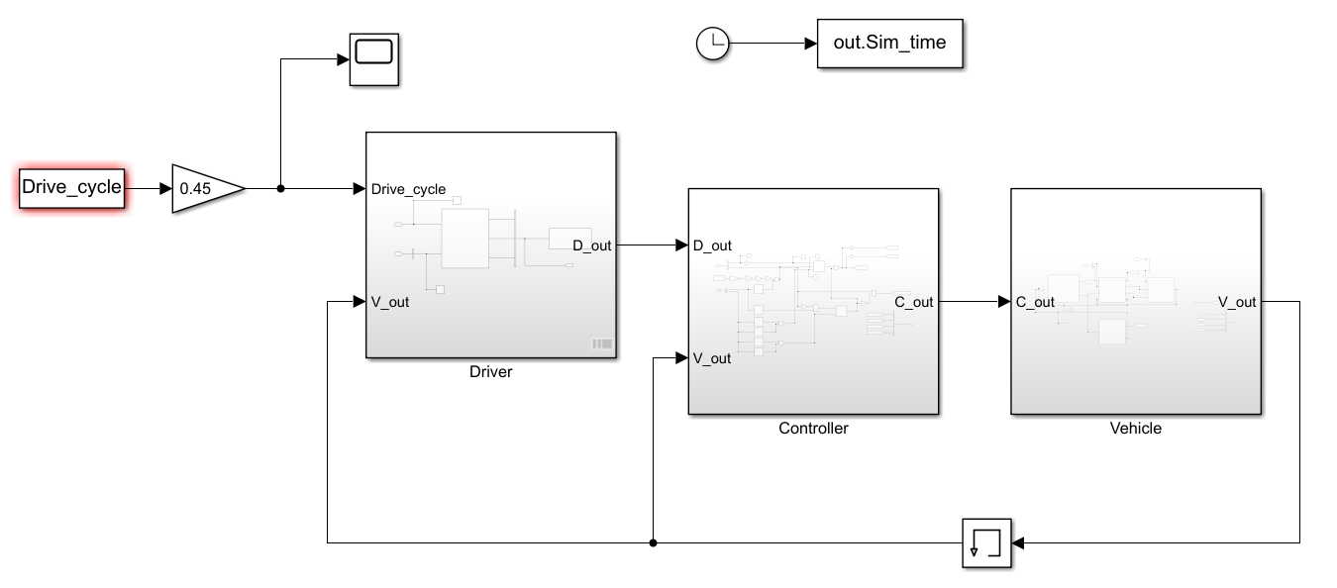

Figure.3 The modelling structure

The function of the driver module is to evaluate the gap between drive cycle speed and EV chassis speed, and from this, calculate the propulsion torque and braking torque required to make up the gap.

The controller module acts as a bridge between the other two modules and adjusts the torque distribution of the dual motors through the input torque demand. In addition, the force provided by the regenerative braking brake is distributed according to the coefficient of friction and the force provided by the friction brake. Finally, the module outputs motor control commands.

The vehicle module is used to simulate the key components inside the vehicle, such as the battery, motor, electrical accessories and chassis. Details will be explained in the following parts.

* 1. *Modeling battery & electrical accessories*

The battery and electronic accessory modules are necessary for the whole system, and these carry over from the ECE724 Chevrolet Spark. Electronic accessories include basic power consumption in the car, such as air conditioners and onboard computers. This project set the base power to consume 300W.

The battery module's duties are to calculate the battery's State of Charge (SOC) and output voltage. The SOC value evaluates the power consumption of the motor and electronic accessories. Moreover, according to the floating of SOC, the corresponding voltage floats based on the lookup table.

* 1. *Modeling motor*

The motor module is shown in figure 4. The system has two motors, which respectively receive the torque demand from the controller. The front and rear motors' configurations are through how to allocate the torque from controller. 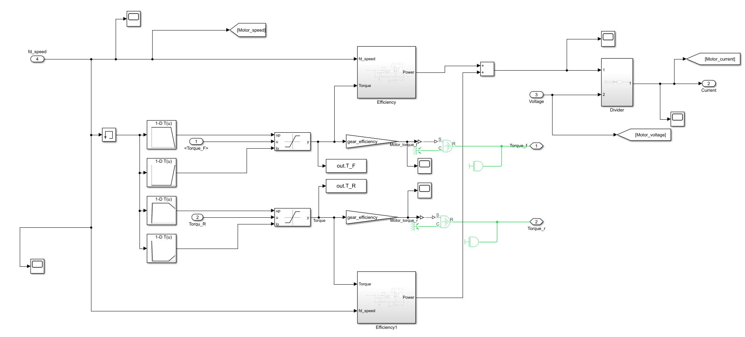

Figure.4 The motor

The front motor is a Tesla 3D3 induction motor, and the rear motor is a Tesla 3D1 permanent magnet synchronous motor. Moreover, different motor speed and torque requirements will affect the working efficiency of the motor. figures 5 and 6 are efficiency maps.

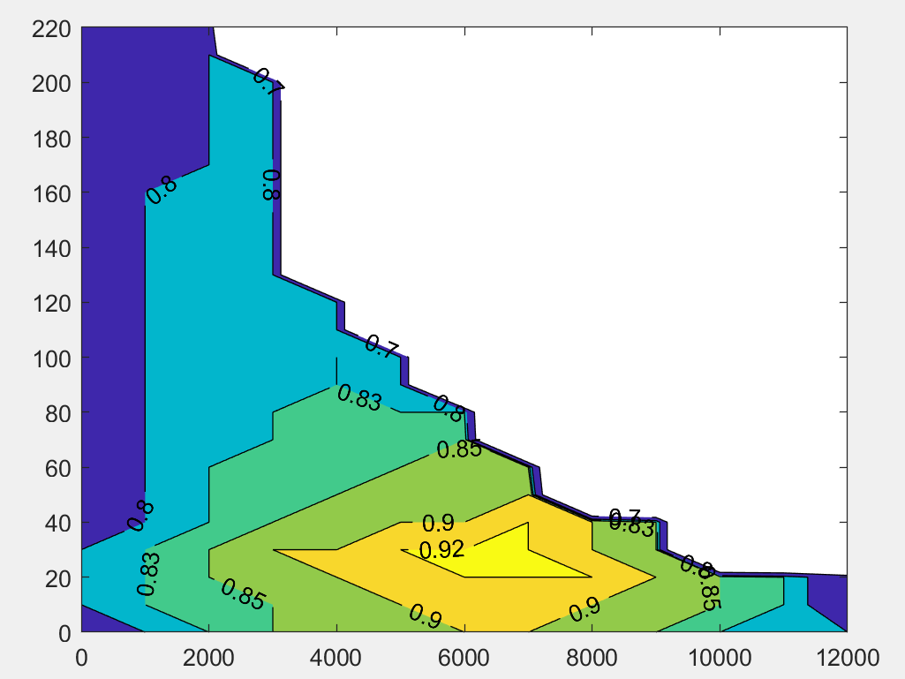

Figure.5 The 3D3 efficiency map

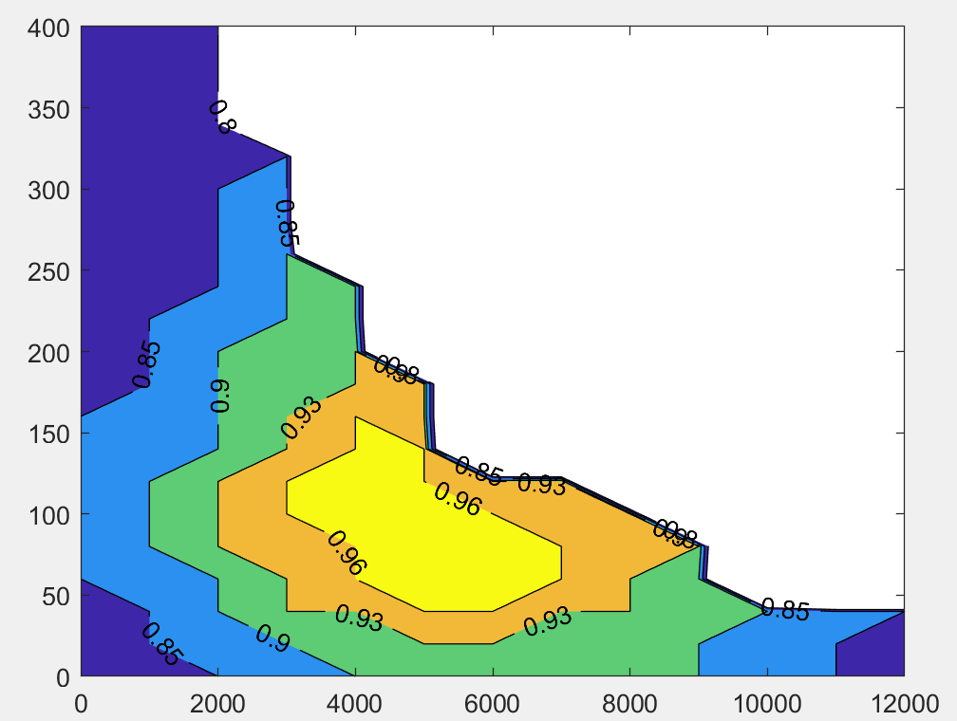

Figure.6 The 3D1 efficiency map

* 1. *Modeling chassis*

The Chassis module includes two axles, four-wheel modules and a vehicle body. The front and rear axles of Tesla model 3 have independent final drivers, and each final driver connects with a motor to drive two wheels. The wheel module is driven by torque from gear. It is also affected by rotational inertia. The wheel model will output slip information and rotational speed information. Finally, the vehicle body aggregates all forces (including propulsion and various resistances) and outputs the final chassis speed.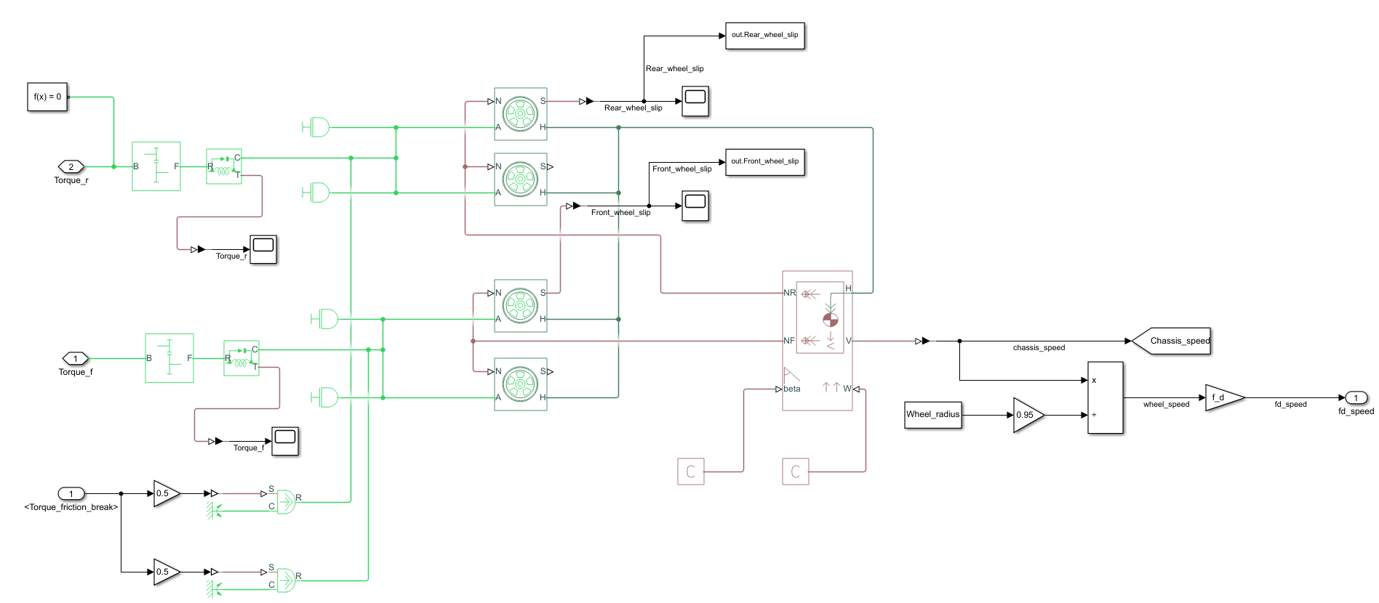

Figure.6 The chassis

1. Simulation results

The drive cycle which uses to simulate the EV road test is shown in figure.7, and the test sequence is UDDS#1, HWY, UDDS#2, US06. This drive cycle includes urban and high-speed driving, normal driving and aggressive driving.

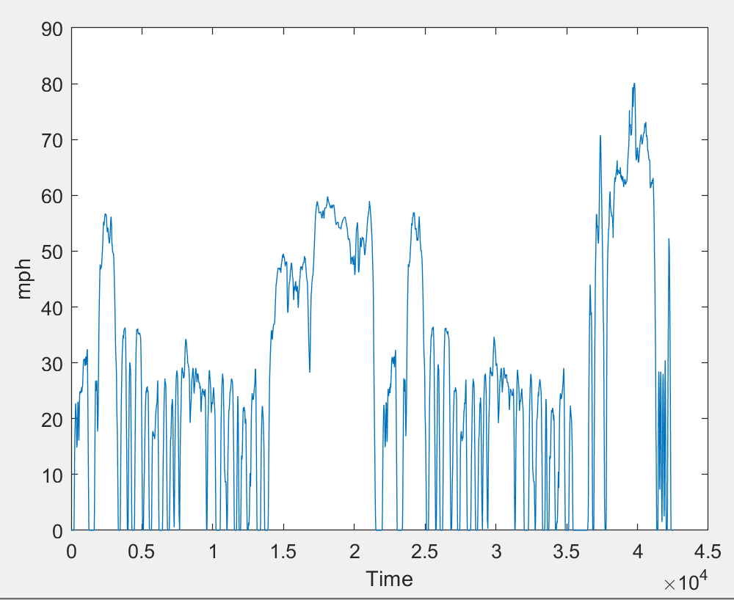

Figure.7 The driver cycle

The torque inputs for different torque split strategies are as follows.

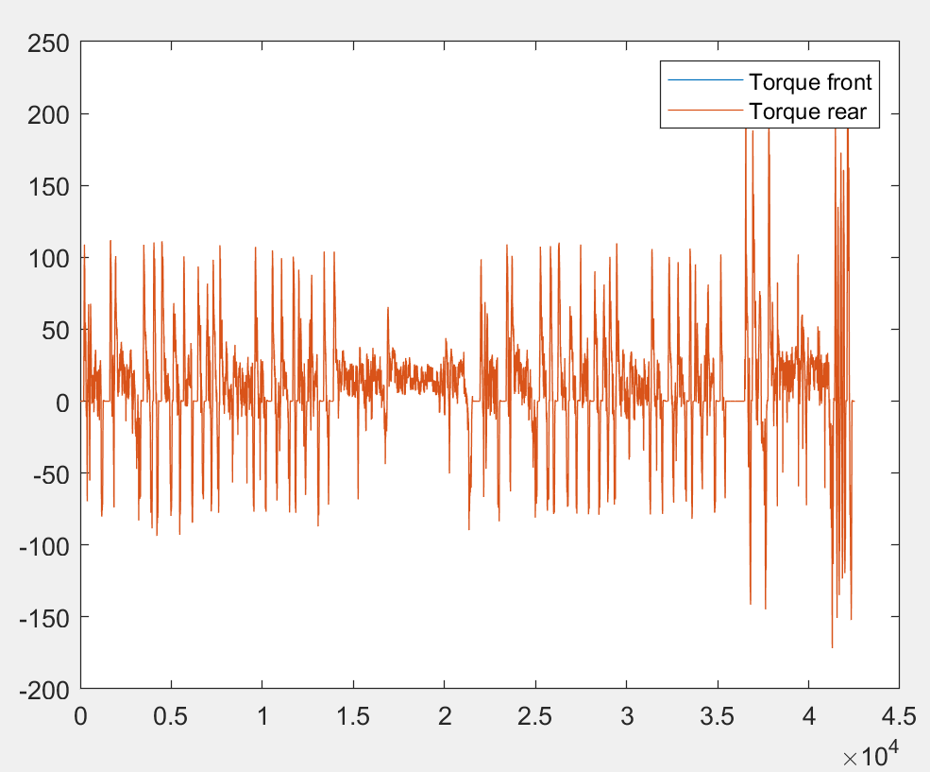

Figure.8 50/50 constant split

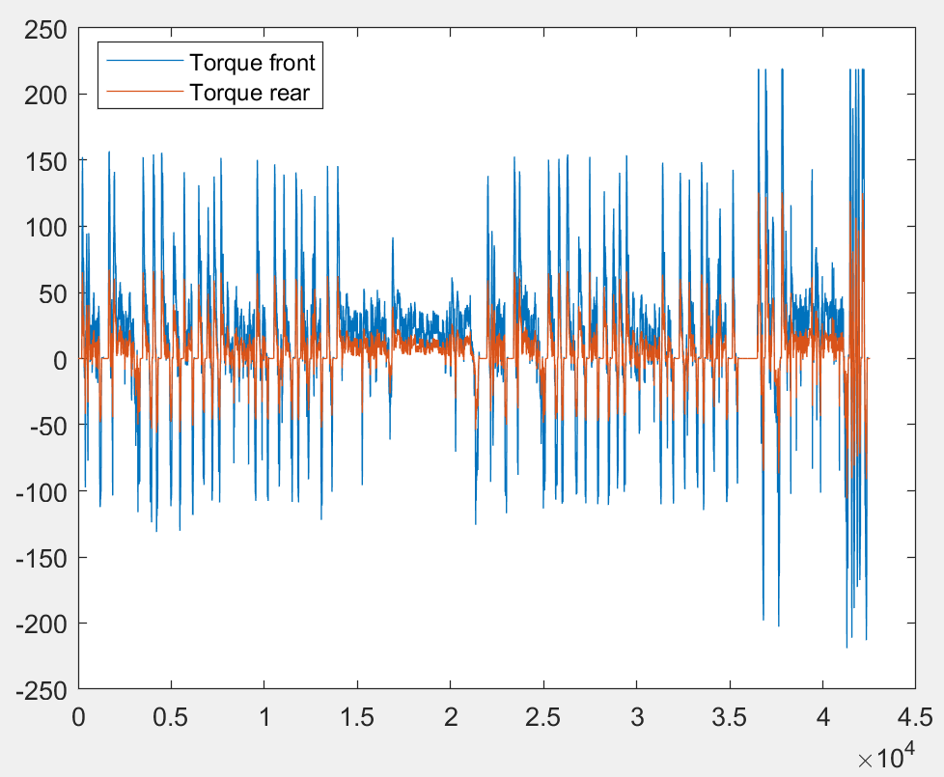

Figure.9 30/70 constant split

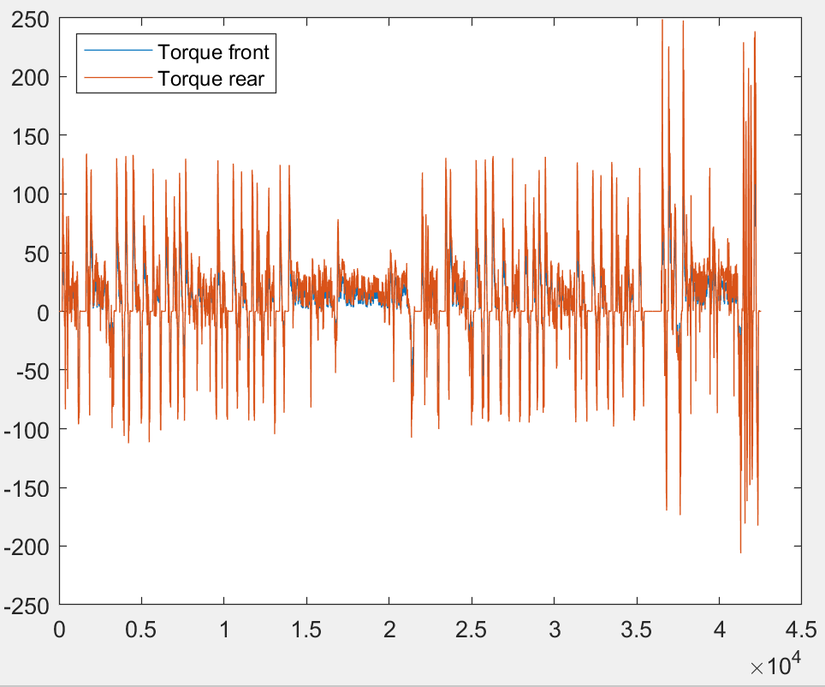

Figure.10 60/40 constant split

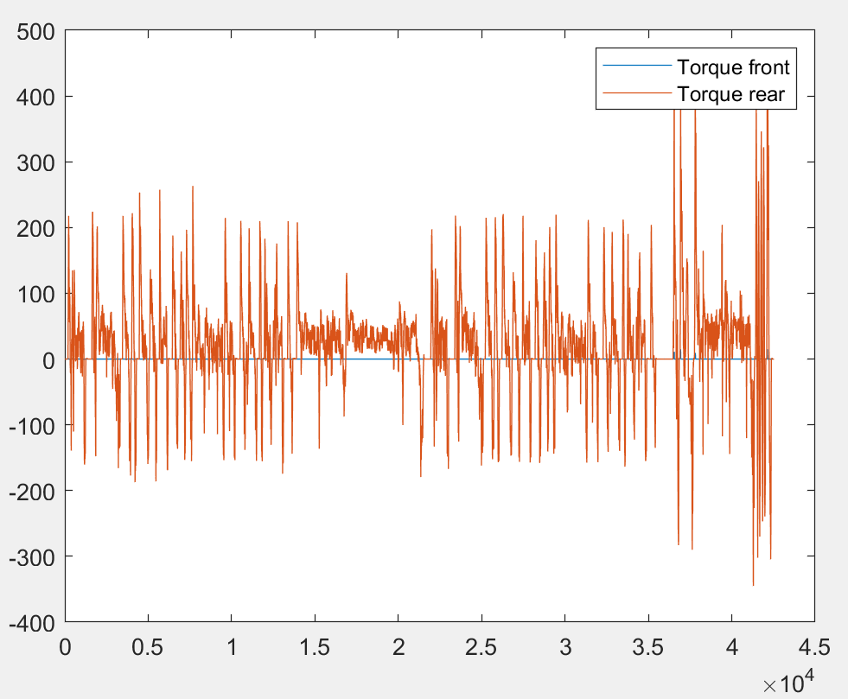

Figure.11 Overflow method

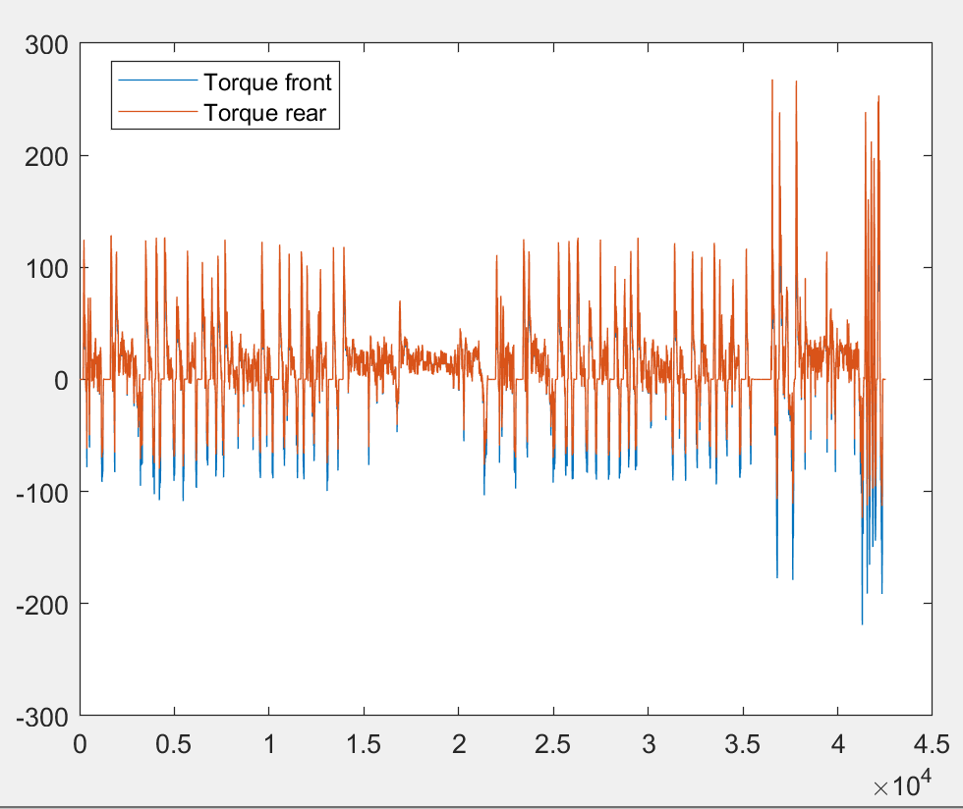

Figure.12 Axle load distribution method

According to the slip ratio function (5), is the real-time wheel speed and V is the ideal wheel speed. The torque split strategies are considered safe if the slip ratio is less than 0.1.

(5)

As shown in the figures, all the torque split strategies` slip ratio under 0.1.

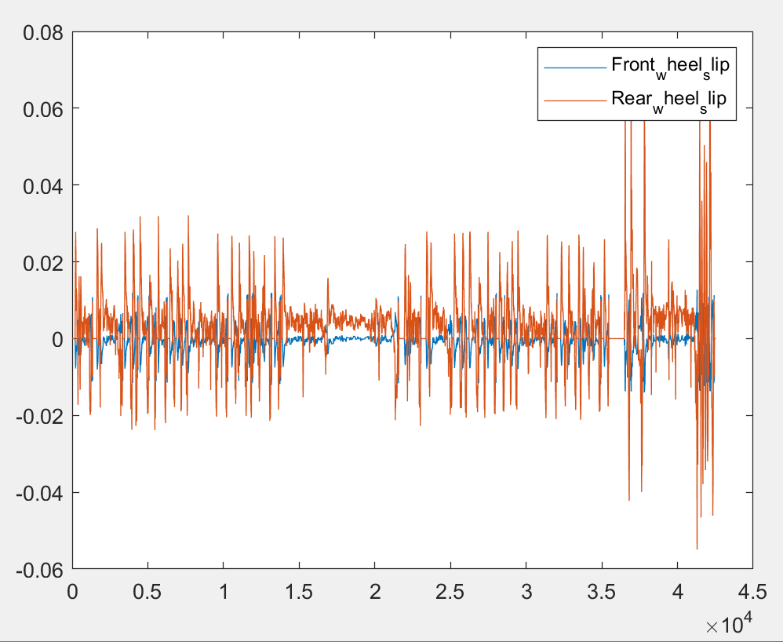

Figure.13 50/50 constant split slip ratio

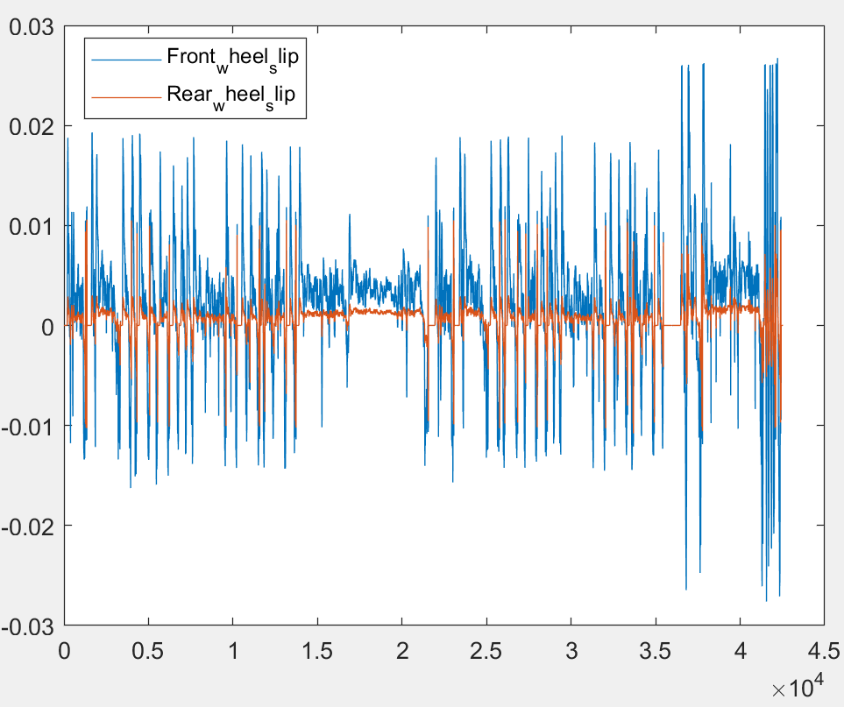

Figure.14 30/70 constant split slip ratio

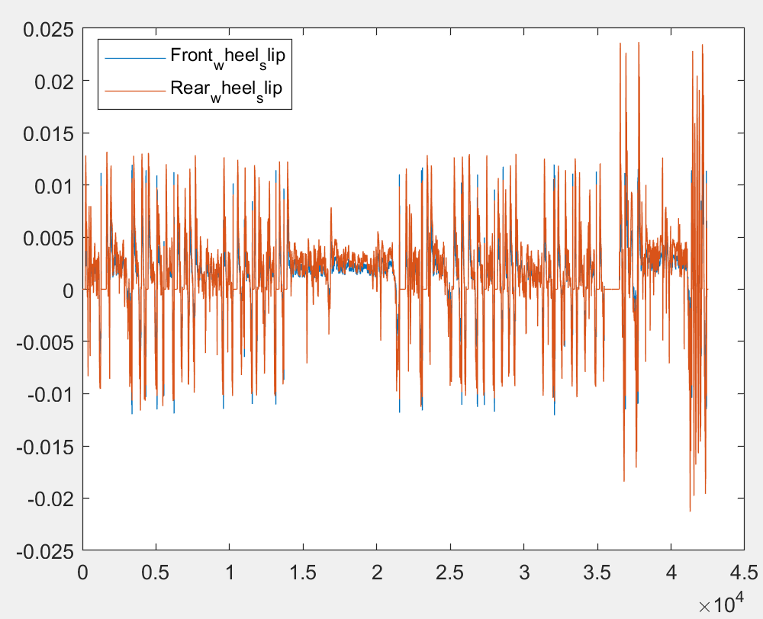

Figure.15 60/40 constant split slip ratio

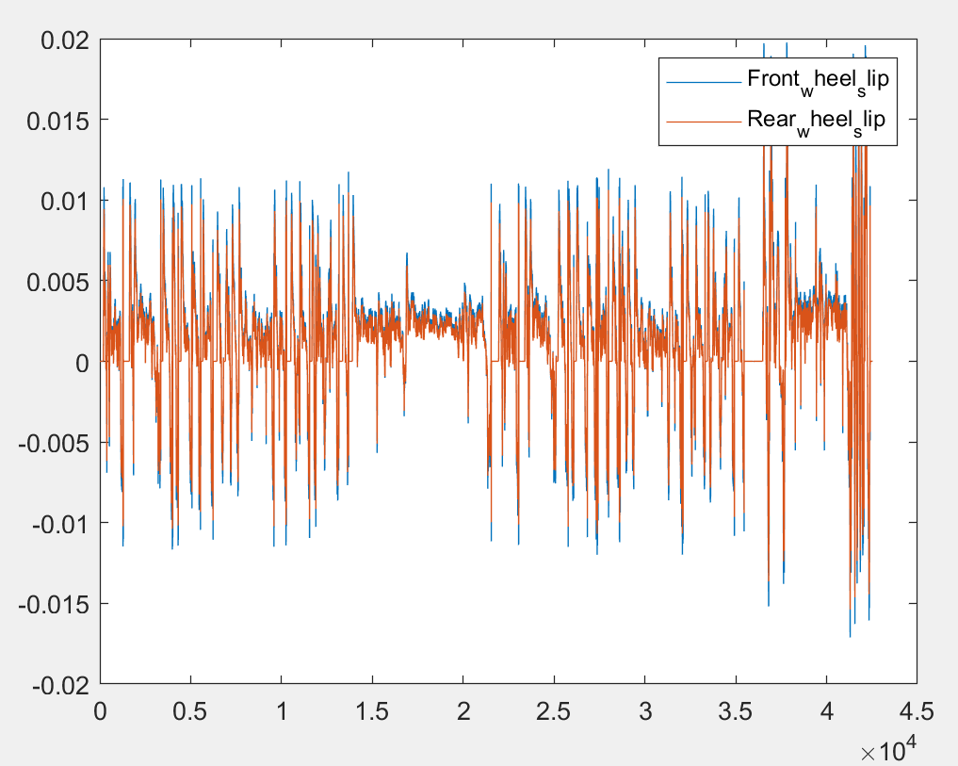

Figure.16 Overflow method slip ratio

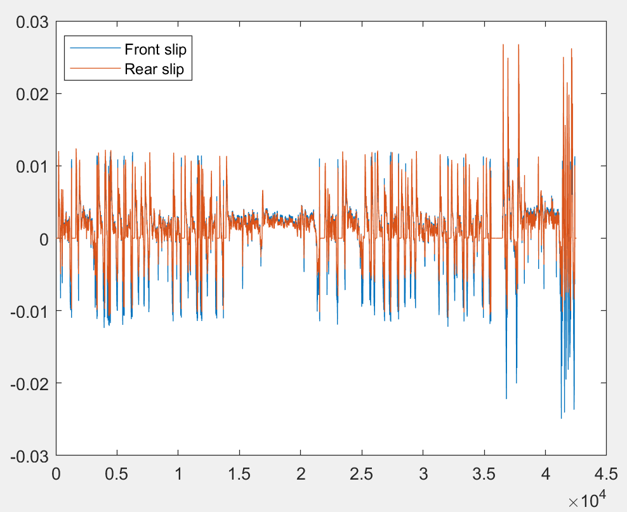

Figure.17 Axle load distribution method slip ratio

This project conducts drive cycle tests on three strategies, constant split slip, overflow method and axle load distribution method. Among these strategies, the constant split slip is divided into five mainstream torque splits: 100/0, 60/40, 50/50, 30/70, and 0/100. The energy consumption results are shown in the figure. 18, and the SOC remain plot is shown in the figure. 19.

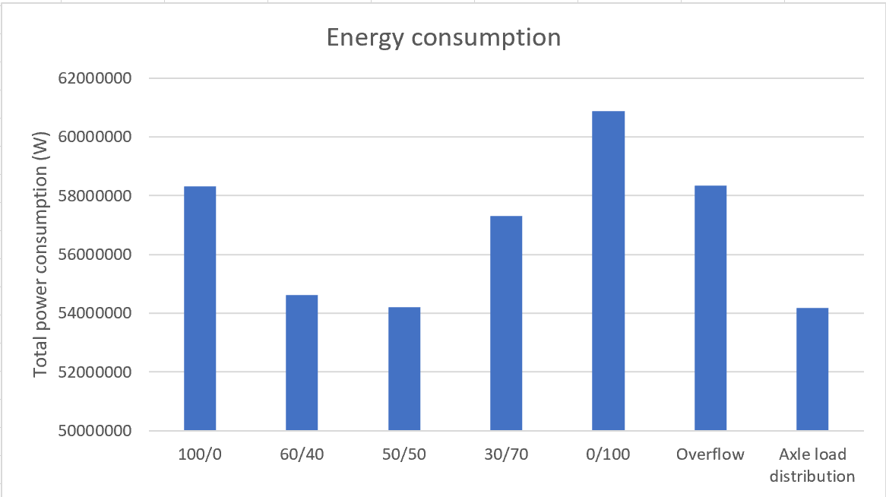

Figure.18 The energy consumption

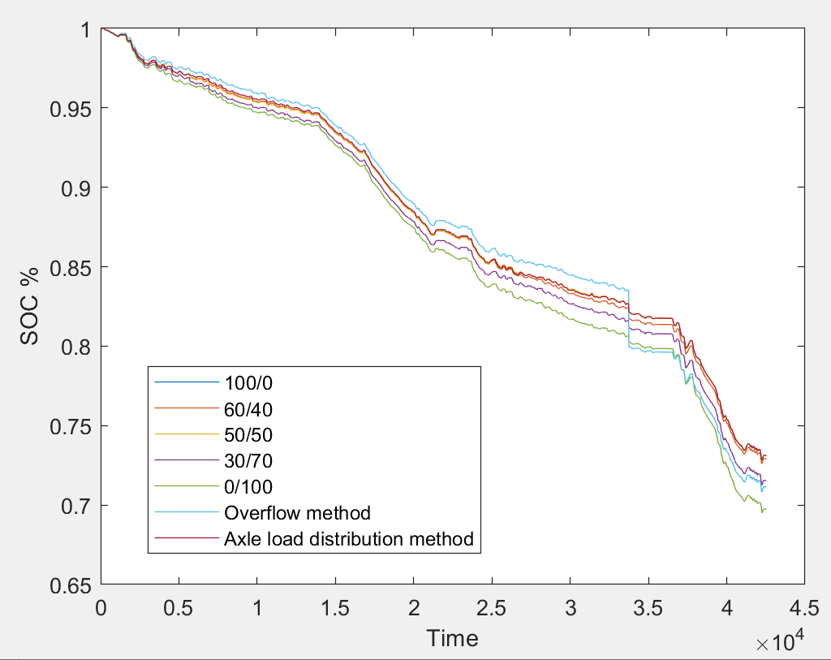

Figure.19 The SOC remain

As a reference experiment, the next step is to simulate the Tesla model 3 single-motor RWD model. With one less motor and smaller battery capacity, the RWD version is 238kg lighter for a total weight of 1612kg. Its total energy consumption is 5.7E7 watts. The energy consumption plot is shown in figure 20.

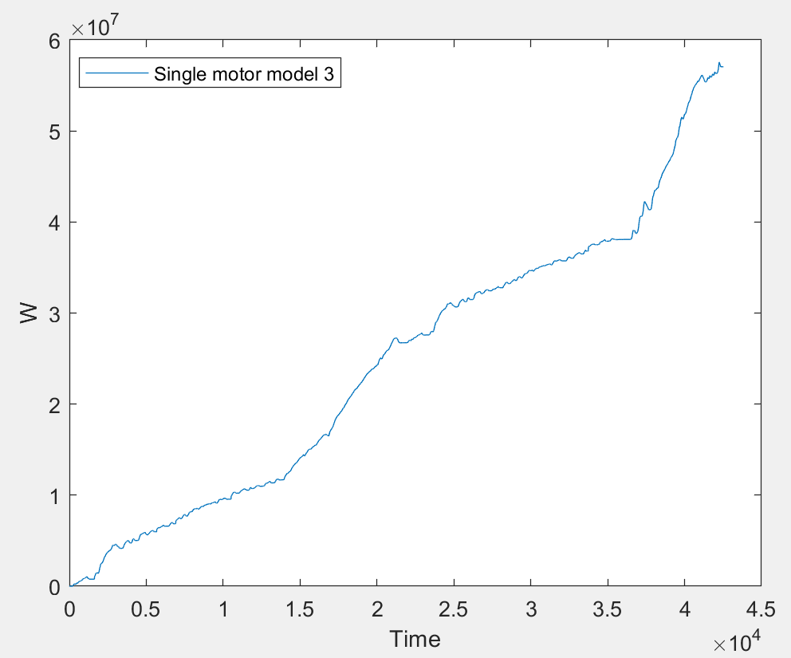

Figure.20 The Single motor model 3 energy consumption

1. Conclusion

This paper mainly uses a dual-motor Tesla model 3 AWD as a model to simulate three different torque distribution strategies. After the specified drive cycle dynamometer test, the energy consumption of each strategy is evaluated. At the same time, based on the model of Tesla model 3 AWD, the energy consumption performance of Tesla model 3 RWD is tested.

The test results show that the axle load distribution method is the most energy-efficient strategy. This method saves energy and maximizes driving comfort because dynamic torque adjustment reduces the discomfort caused by motion inertia and makes the system more stable.

The constant split method achieves the highest efficiency of the motor at 50/50. If more torque is added to the front or rear axle, the efficiency will decrease, and the greater the torque gap between the two axles, the efficiency will also decrease. The reason of this phenomenon is whether it is a PMSM or an IM motor, the most efficient working area is in the mid-speed and mid-torque range. Also, 100/0 is more efficient than 0/100, for PMSM is more efficient than IM at low torques because PMSM doesn't need to consume power to magnetize the rotor.

The principle and energy consumption of the overflow method are similar to 0/100. The rear axle motor is the main driving force, which leads to the long-term low torque and low efficiency of the front axle IM motor.

The single motor model 3 RWD has energy consumption under 100/0, 30/70, 0/100 and overflow and axle load distribution method due to lighter vehicle body. However, due to the lack of a flexible torque distribution mechanism, the motor efficiency cannot be dynamically improved. The best performance of the single motor is slightly weaker than the dual motor version, so the effective use of the dual motor EV torque split can offset the energy consumption penalty caused by the increased motor weight.

7.References

[1] Lévay, P. Z., Drossinos, Y., &amp; Thiel, C. (2017). The effect of fiscal incentives on market penetration of electric vehicles: A pairwise comparison of total cost of ownership. Energy Policy, 105, 524–533. https://doi.org/10.1016/j.enpol.2017.02.054

[2] Buekers, J., Van Holderbeke, M., Bierkens, J., &amp; Int Panis, L. (2014). Health and environmental benefits related to electric vehicle introduction in EU countries. Transportation Research Part D: Transport and Environment, 33, 26–38. https://doi.org/10.1016/j.trd.2014.09.002

[3] U.S. Department of Energy, O. R. N. L. (2021). Compare side-by-side. www.fueleconomy.gov - the official government source for fuel economy information. Retrieved April 9, 2022, from https://www.fueleconomy.gov/feg/Find.do?action=sbs&amp;id=43401

[4] Hu, X., Li, Y., Lv, C., &amp; Liu, Y. (2019). Optimal Energy Management and sizing of a dual motor-driven electric powertrain. IEEE Transactions on Power Electronics, 34(8), 7489–7501. https://doi.org/10.1109/tpel.2018.2879225

[5] Wang, W., Zhang, Z., Shi, J., Lin, C., &amp; Gao, Y. (2018). Optimization of a dual-motor coupled powertrain energy management strategy for a battery electric bus based on dynamic programming method. IEEE Access, 6, 32899–32909. https://doi.org/10.1109/access.2018.2847323

[6] Mutoh, N., &amp; Yahagi, H. (2006). Methods to control wheel locks and wheel spins for electric vehicles with the structure having independently driven front and rear wheels. Conference Record of the 2006 IEEE Industry Applications Conference Forty-First IAS Annual Meeting. https://doi.org/10.1109/ias.2006.256742

[7] Oh, M., &amp; Husain, I. (2021). Optimal torque distribution of dual-motor all-wheel drive electric vehicles for Maximizing Motor Energy Efficiency. 2021 IEEE Transportation Electrification Conference &amp; Expo (ITEC). https://doi.org/10.1109/itec51675.2021.9490089

[8] Straubel, J. B. (2016, January 22). Tesla All Wheel Drive (dual motor) power and torque specifications. Electric Cars, Solar &amp; Clean Energy. Retrieved February 7, 2022, from https://www.tesla.com/blog/tesla-all-wheel-drive-dual-motor-power-and-torque-specifications

[9] Huynh, T., &amp; Hsieh, M.-F. (2018). Performance Analysis of Permanent Magnet Motors for electric vehicles (EV) traction considering driving cycles. Energies, 11(6), 1385. https://doi.org/10.3390/en11061385

[10] Spina, I., Del Pizzo, A., Beneduce, L., Cascone, B., &amp; Fratelli, L. (2014). Comparative analysis of performance and energy losses in light railways vehicles equipped with IM or PMSM drive. 2014 International Symposium on Power Electronics, Electrical Drives, Automation and Motion. https://doi.org/10.1109/speedam.2014.6871998

[11] Jishun, L., Jun, L., Qingnian, W., Jiaxue, W., &amp; Jinhu, S. (2011). Study on mechanism of energy saving for Double Motor Configuration Hybrid Electric Vehicle. 2011 International Conference on Mechatronic Science, Electric Engineering and Computer (MEC). <https://doi.org/10.1109/mec.2011.6026024>

[12] Lee, J., Nam, K., Choi, S., &amp; Kwon, S. (2007). A lookup table based loss minimizing control for FCEV permanent magnet synchronous motors. 2007 IEEE Vehicle Power and Propulsion Conference. https://doi.org/10.1109/vppc.2007.4544120

[13] Roscher, M. A., Michel, R., &amp; Leidholdt, W. (2013). Improving energy conversion efficiency by means of power splitting in dual drive train EV applications. International Journal of Vehicular Technology, 2013, 1–5. <https://doi.org/10.1155/2013/398361>

[14] Mendes, C. J. (2006). Torque Control Strategies for AWD Electric vehicles. uwspace. Retrieved March 29, 2022, from <https://uwspace.uwaterloo.ca/bitstream/handle/10012/2735/Thesis_for_formatting_review%20-%20revised.pdf?sequence=1>

[15] Yiqiliuxia, J. Y. (2020). 纯电四驱车扭矩分配Simulink仿真. 知乎专栏. Retrieved April 14, 2022, from https://zhuanlan.zhihu.com/p/106283106